



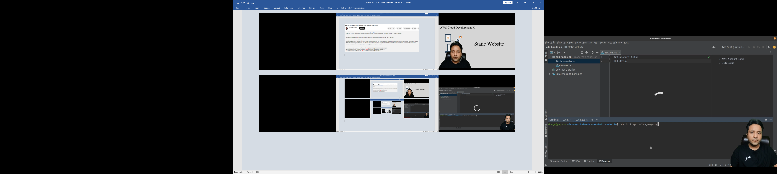

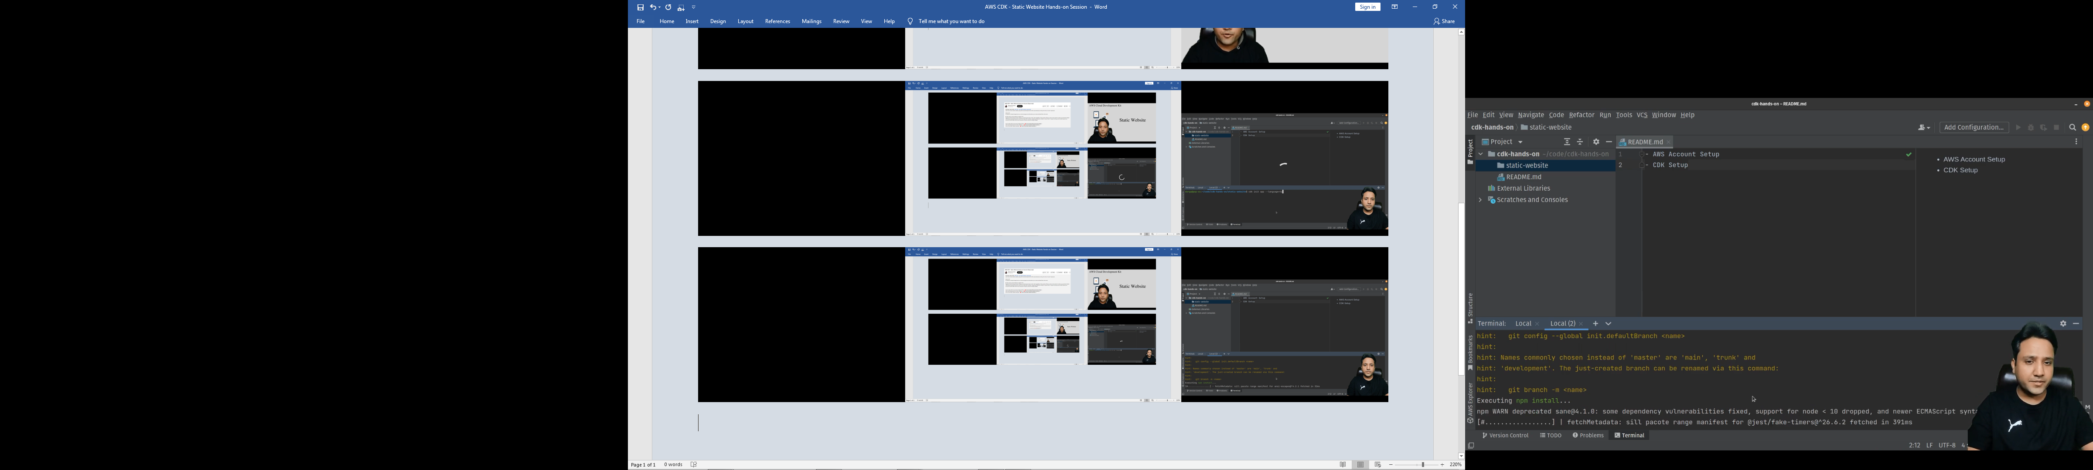



The CDK app creation process is completed.



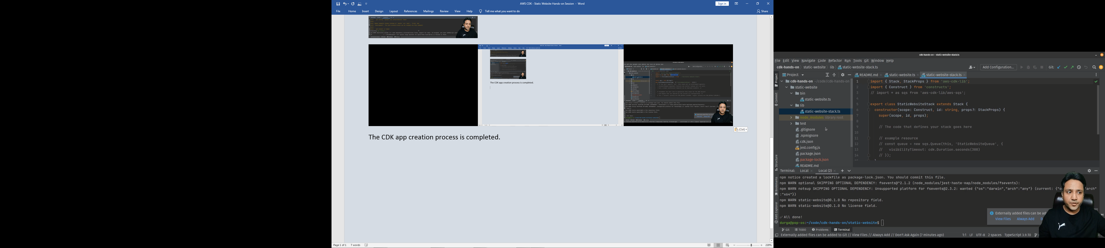





Change the **cdk** library from the **aws-cdk-lib** to use the AWS CDK Core library as above



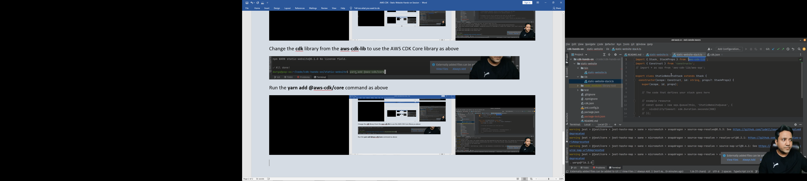

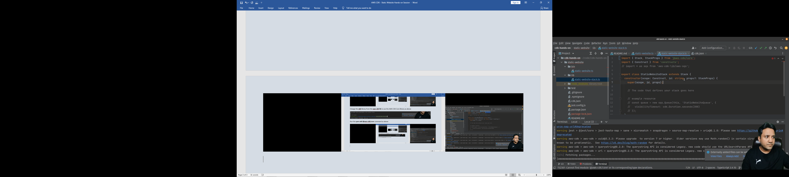

Run the **yarn add @aws-cdk/core** command as above

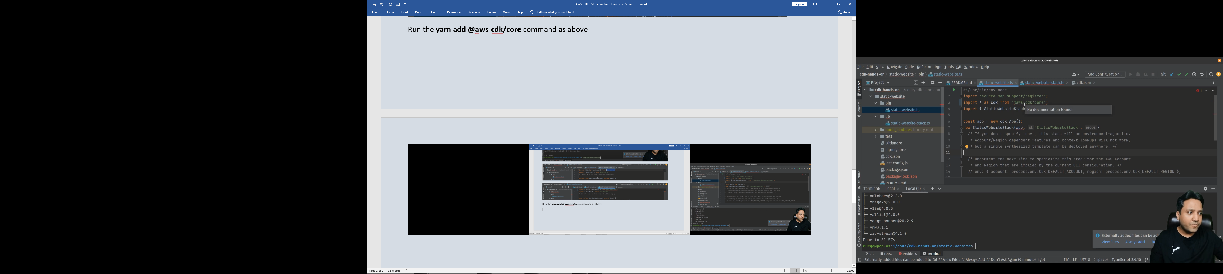









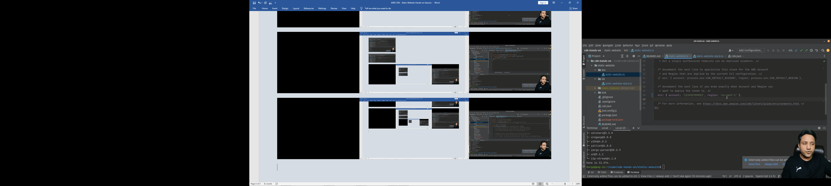

You can uncomment this line if you are targeting a different region



For a static website we need to include some libraries

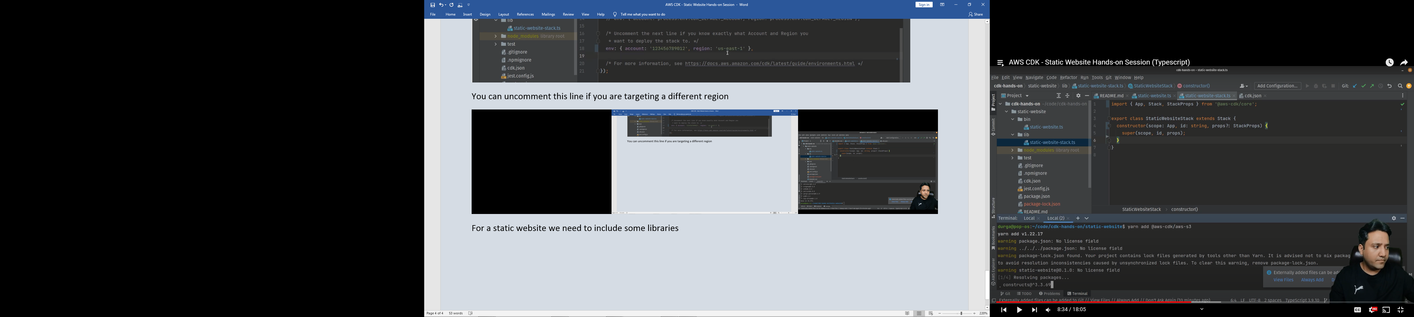

Do **yarn add @aws-cdk/aws-s3** command



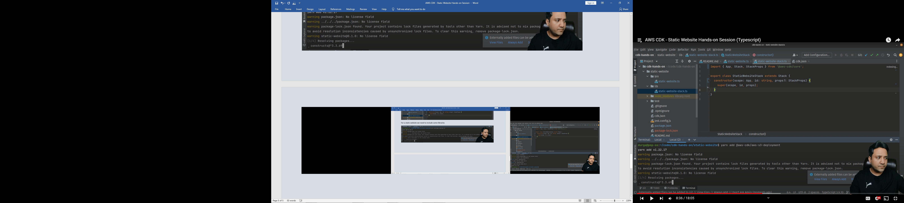

Do **yarn add @aws-cdk/aws-s3-deployment** command



